**Opensource Team Projecct**

Expiration date management program manual

**Developers**

joonhyeok10

lds6210

20144804

Yuujung

**Program features**

Our program is a program that manages the expiration date.

You can easily manage the expiration date with this program.

**manual**

You can register the desired product and its expiration date.

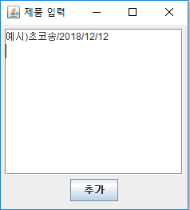

Enter the desired ‘product name/year/month/date’ as shown in the image above.

If you enter, the product will be registered as follows.

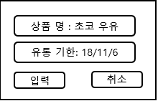

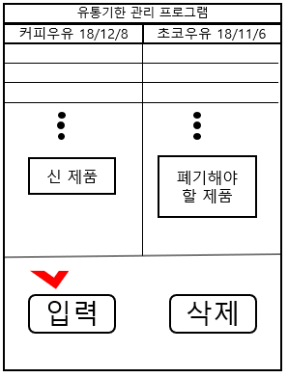

Registered products are divided into two groups.

The products on the left are those with a enough expiration date period and those on the right are within 3 days.

The product on the left will automatically move to the right when its expiration date decreases to less than 3 days.

Thank you for using our project.

If there's something you want to correct, please visit our github <https://github.com/joonhyeok10/OSS_Project_J>

We welcome any comments.